A60-AM,S-Colombia-Tairona-Gold Figurine-Mama Priest-1000-1500 CE



**Case No.: 7**

**Formal Label: Colombia Tairona Culture**

**Display Description:**

The Tairona culture of the Sierra Nevada de Santa Marta in n Colombia have as their ethno-linguistic Chibcha descendants the Kogi (aka Cogui, Kaggaba; pop. 9,770, SIL 2000), the Malayao (aka Arosario, Guamaka, Marocasero, Sanja, Sanka, Wiwa; pop. 3,225 Organización Gonawindúa Tayrona 1993), the Arhuaco (aka Bintuk, Ika, Ijca; pop. (27,000) 14,301, Arango and Sanchez 1998) and the Kankuamo (aka Kankui, Kankuaka, Kankuané; pop. 15,000 (World Directory of Minorities and Indigenous Peoples 2006).

Arango, Raúl and Enrique Sanchez . 1998. *Los pueblos indígenas de Colombia, 1997.* Bogota: Tercer Mundo Editores y Departmento Nacional de Planeación.

Organización Gonawindúa Tayrona. 1993.

SIL. 2000.

World Directory of Minorities and Indigenous Peoples. 2006. http://minorityrights.org/minorities/kankuamo/

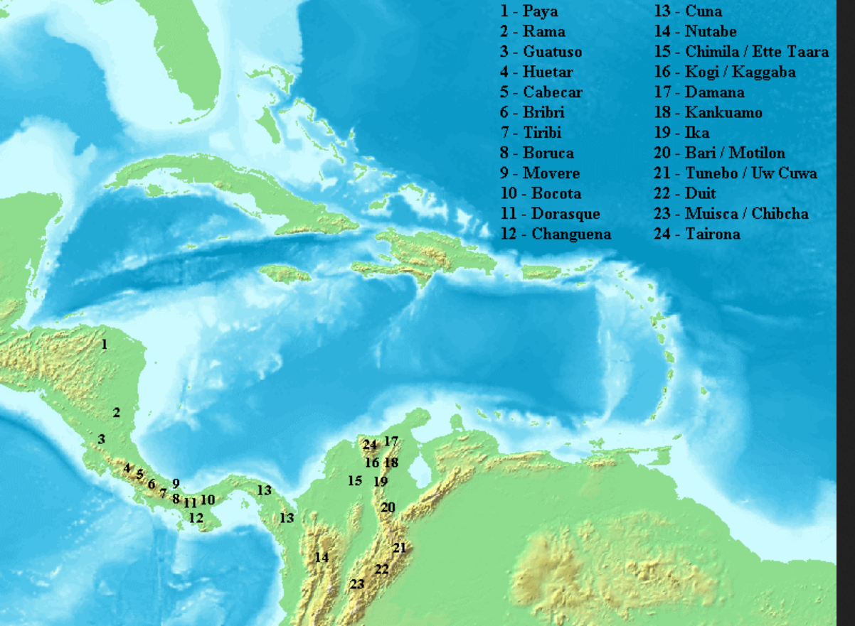

Distribution of Chibchan languages across southern Central and northwestern South America

Muisca

The Muisca inhabited the central highlands ([Altiplano Cundiboyacense](https://en.wikipedia.org/wiki/Altiplano_Cundiboyacense" \o "Altiplano Cundiboyacense)) of what today is the country of Colombia. The name of the language ***Muysccubun*** or *muyskkubun* in its own language means "language of the people" (*muyska* / *muysca* ("people") and *kubun* / *cubun* ("language").[[3]](https://en.wikipedia.org/wiki/Chibcha_language#cite_note-QuickGuide-3) Chibcha in the Chibcha language means "look man!".[[4]](https://en.wikipedia.org/wiki/Chibcha_language" \l "cite_note-4) As one out of four advanced civilizations of the Americas (apart from the [Aztec](https://en.wikipedia.org/wiki/Aztec), [Mayas](https://en.wikipedia.org/wiki/Maya_civilization) and [Incas](https://en.wikipedia.org/wiki/Inca_Empire)),[[2]](https://en.wikipedia.org/wiki/Muisca#cite_note-2) they were encountered by the [Spanish Empire](https://en.wikipedia.org/wiki/Spanish_Empire) in 1537, at the time of their [conquest](https://en.wikipedia.org/wiki/Spanish_conquest_of_the_Americas). Subgroupings of the Muisca were mostly identified by their allegiances to three great rulers: the [*zaque*](https://en.wikipedia.org/wiki/Zaque), centered in [Hunza](https://en.wikipedia.org/wiki/Tunja), ruling a territory roughly covering modern southern and northeastern [Boyacá](https://en.wikipedia.org/wiki/Boyac%C3%A1_Department) and southern [Santander](https://en.wikipedia.org/wiki/Santander_Department); the [*zipa*](https://en.wikipedia.org/wiki/Zipa), centered in [Bacatá](https://en.wikipedia.org/wiki/Bogot%C3%A1), and encompassing most of modern [Cundinamarca](https://en.wikipedia.org/wiki/Cundinamarca_Department), the western [Llanos](https://en.wikipedia.org/wiki/Los_Llanos_%28South_America%29) and northeastern [Tolima](https://en.wikipedia.org/wiki/Tolima_Department); and the [*Iraca*](https://en.wikipedia.org/wiki/Iraca), ruler of [Suamox](https://en.wikipedia.org/wiki/Sogamoso) and modern northeastern Boyacá and southwestern Santander. The territory of the Muisca spanned an area of around 47,000 square kilometres (18,000 sq mi)[[3]](https://en.wikipedia.org/wiki/Muisca#cite_note-3) - a region slightly larger than [Switzerland](https://en.wikipedia.org/wiki/Switzerland) - from the north of [Boyacá](https://en.wikipedia.org/wiki/Boyac%C3%A1_Department) to the [Sumapaz Paramo](https://en.wikipedia.org/wiki/Sumapaz_Paramo) and from the summits of the Eastern Range to the Magdalena Valley. It bordered the territories of the [Panche](https://en.wikipedia.org/wiki/Panche_people) and [Pijao](https://en.wikipedia.org/wiki/Pijao_people) tribes.

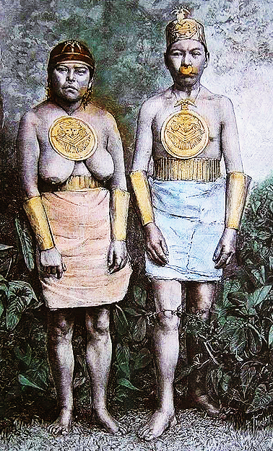

***Indiens Muysca pares de bijoux anciens* (“Muisca Indians wearing antique jewelry”).** Photograph by M Chaffanjon, wood engraving by M. Thiriat. In Reclus 1875-94 (18): 38.

The major sources that have preserved ancient Tairona iconography are rock art and gold objects that have encoded myths and rituals. Rock art in the Tairona heartland of the Sierra Nevada de Santa Marta predates Tairona gold working which began in the Neguanje Period (ca 300-800 AD/CE).

Tairona spirituality was predicated on a holistic principle of between nature and psyche that differed from Roman Catholic priests who based their teaching on law (Moses’ Decalogue) and punishment (Canon Law). Among the Kogi, couples were free to divorce and women were free to abort a fetus. Homosexuality and transsexuality (a form of the berdash) were accepted among the Kogi, and women as well as men were empowered in religion. The Roman Catholic Church and its male priests objected violently to these practices that challenged their authority, especially the spiritual activities that went on behind the closed doors of the Tairona men’s house, where adult men meditated preparatory to assuming their shamanic rôles a *mamas*. Kogi raise their shamans or *mamas* in isolation from the village without distractions so that they may know the inner music of the cosmos. The Kogi believe that the world of the spirit, or *aluna,* is impacted by the physical world so that our actions have spiritual consequences.

In order to discern what these consequences are, a practice of divination requires both the diviner and his/her subject(s) to believe in *aluna*. Hollow gold beads called tumas colored red, black, white and green are dropped into a golden bowl tu-tima of water, and each color has its range of subjects:

Red - blood, illness  
Black - death  
White - abu, the primeval spirit of the ocean, Mother   
Green - all green vegetation.

Then mamas are queried about problems regarding the community. The primary mission of each mama is to keep a balance of each component in

the heart of the world’ and its ecosystem where they live, both physical and spiritual ([aluna](http://ritualgoddess.com/the-kogi-world-of-aluna-spirit/)): It may be understood as speaking with ancestors, because physical death is not the extinction of life, only its transition from the body, but that alone would be a travesty of it. Nor is it enough to understand divination as a way of receiving messages from gods, though aluna is the Mother, and the Mother is listened to by divining. Divination is the reading of signs. Since everything that happens is an event in the world of aluna, everything that happens also reflects that world. To put a question is an act in aluna, an act of pure thought, and if it is properly put then its answer is instantaneously present, here in the physical world as well. Divination is the mental process of properly shaping a question, and the highly formal process of reading the answer.

Ereira also states, however, that divination can only exist in a context of a people who believe in [aluna](http://ritualgoddess.com/the-kogi-world-of-aluna-spirit/). “Divination would also, of course, be meaningless if there were no higher reality, no world of aluna where all things have their essence and all things are bound together in a single life.”

Aluna is an alive presence in everything and all is deeply connected and interwoven. There is one whole. Actions anywhere affect the whole. Therefore we too can have an affect on the aluna and we do whether conscious of it or not.

Divination brings conscious engagement between humans and aluna. This is but one more beautiful articulation of the ancient art of divination.

In what follows we shall try to correlate the images of rock art as predecessors to images in gold figurines that were used as pendants using the lost-wax process. Rock art and gold objects preserve a variety of images including caciques (rulers), shamans, deities, and symbolic animals, birds and reptiles, all of which participate in myths of the Tairona cosmos.

For instance, figurines embody through gestural attitudes unspoken communications to the people. Shamans on the other hand could invoke the spirit of a particular animal by adorning his/her body with a particular figurine which would also communicate an unspoken message. For instance, bats and “bat-man” figurines were quite popular because a bat’s visionary powers enabled sight into the unknown, like that of the shaman. Other popular fauna included birds of prey, felines, crocodiles and snakes, the spirits of which were invoked to maintain equilibrium in the community, to cure diseases and to mediate between members of the community and the deities. Pietro Martire d'Anghiera (1457-1526), an Italian historian in service to Spain compiled his *Decades* and *De Orbe Novo* portrayed the Tairona as living peacefully in densely populated farming valleys, with coastal fleets dedicated to fishing and with a lively cross-cultural trade.

The time of peace came to an end in 1599 when the Spanish began to violently implement the encomienda system by raping women, enslaving children and stealing gold. When the Tairona violently resisted in 1600, the Spanish responded by trying two Tairona Chiefs (Chengue and Bonda), by sentencing them to death by dismemberment, by burning their villages, and by putting their people into concentration camps. Those who could, fled to the remote upper reaches of the Sierra Nevada de Santa Marta. This encounter with the Spanish was so devastating and complete that Tairona descendants, the Kogi, still remain *incommunicado* from all Europeans and Americans in the mountains.

**Accession Number:**

**LC Classification:**

**Date or Time Horizon:**

**Geographical Area:** Sierra Nevada de Santa Marta**, Colombia**

**Map, GPS Coordinates:**

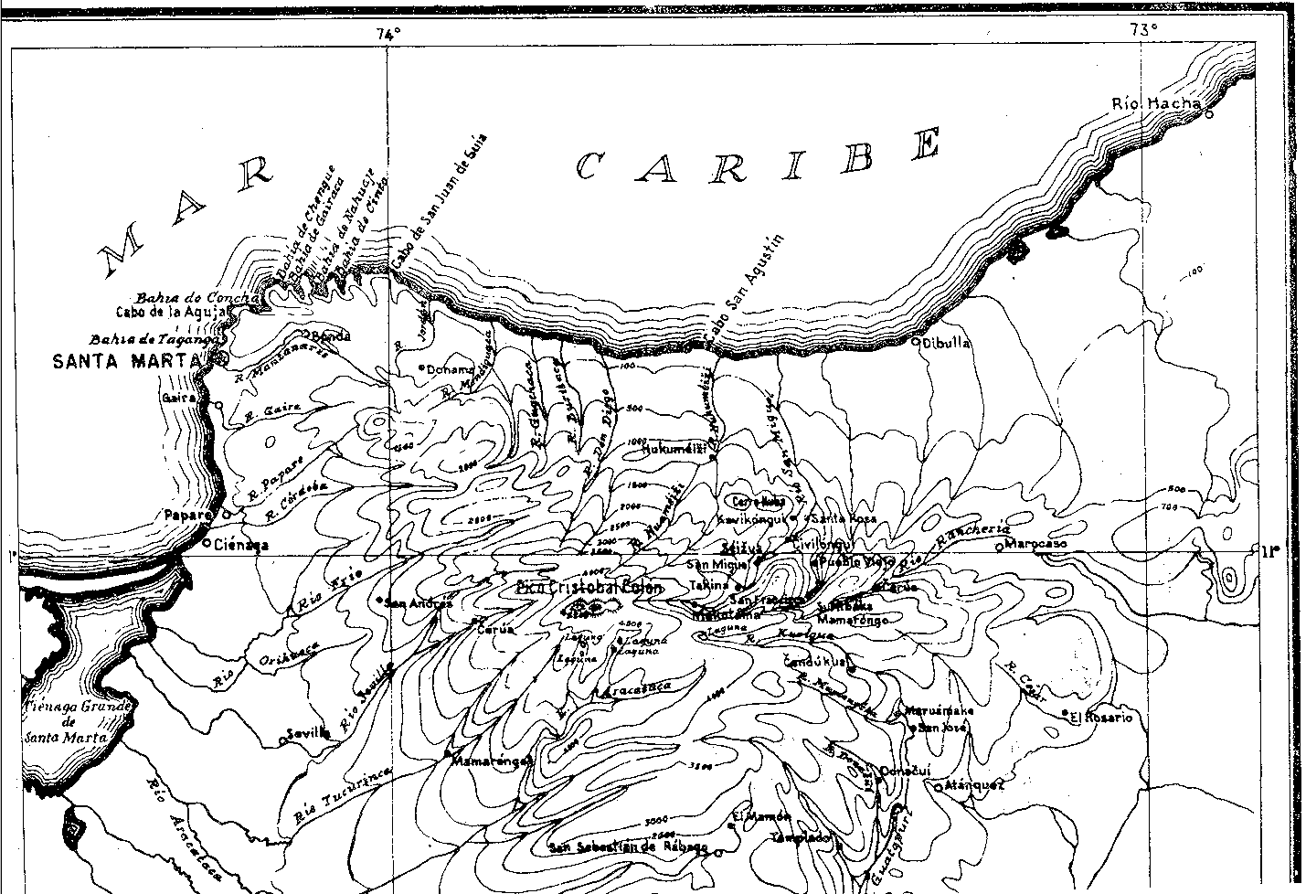

From Reichel-Dolmatoff 1950.





From Mason 1931.

Mason, John Alden Mason. 1931*. Archaeology of Santa Marta, Colombia.* Marshall Field archaeological expedition to Colombia. Chicago: Field museum of Natural History.



Provinces of Colombia ca. 1600.

**Cultural Affiliation:**

**Medium:**

**Dimensions:   
Weight:**

**Provenance:**

**Condition:**

**Discussion:**

The **Sierra Nevada de Santa Marta** at 5,700 m (18,700 ft) asl just 42 km (26 mi) from the Caribbean is one of the world's highest coastal ranges encompassing 17,000 km2 (6,600 sq mi) and the source of 36 rivers.

It also has signiﬁcant cultural wealth in two important archeological sites: Pueblito or Chairama and Teyuna or the Lost City, as well as four communities of the Kogis, Arhuacos, Kankuamos and Wiwas with a tital population of over 35,000 (Ulloa, 2004; Viloria de la Hoz, 2006). The ancestral territory is divided by an imaginary black line, called the ‘‘Line of Origin’’ by the Kogi, which borders the Sierra Nevada de Santa Marta and connects, through radial lines, 54 sacred sites with Gonawindúa, or Pico Bolivar which the government of Colombia has recognized in Resolutions 002 and Resolution 837 that guarantee access to the *mamas* (indigenous priests) to these sites which they consider as the heart of the order in the cosmos governed by The Law of the Mother, or Law of Origins, that governs the world and ensures it to thrive (Duque Cañas, 2009).

**Exploring Ancient Skies: A Survey of Ancient and Cultural Astronomy**

By David H. Kelley, Eugene F. Milone p. 437

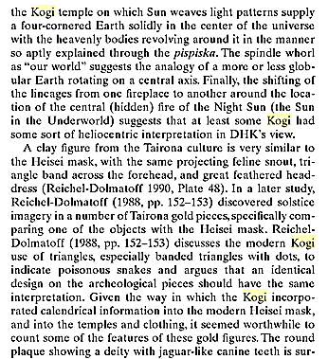 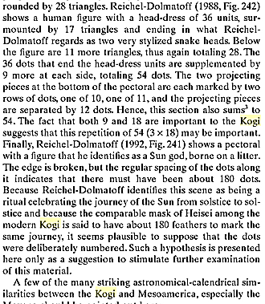 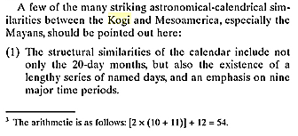

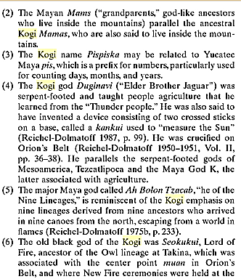 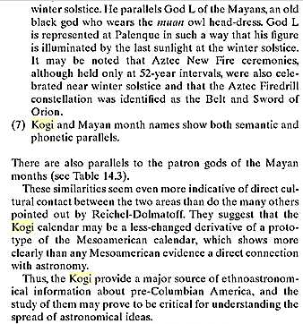

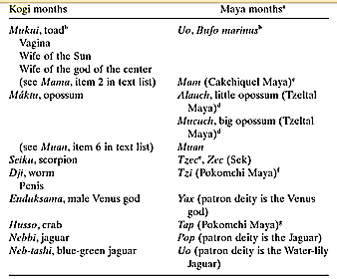 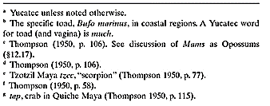

References

Ereira, Alan. [The Elder Brothers](http://www.amazon.com/Elder-Brothers-Alan-Ereira/dp/0679743367/ref=tmm_pap_swatch_0?_encoding=UTF8&sr=&qid=)

Réclus, Élisée. 1875-94. La Nouvelle Géographie universelle, la terre et les hommes, 19 vol. Paris.

Bischof, H. 1982-1983. “Indígenas y españoles en la Sierra Nevada de Santa Marta, siglo XVI,” Revista Colombiana de Antropología vol. 24, pp. 75-124

Bray, W. 2003. “Gold, Stone, and Ideology: Symbols of Power in the Tairona Tradition of Northern Colombia,

in: Quilter J., J.W. Hoopes (eds.), Gold and Power in Ancient Costa Rica, Panama, and Colombia, Washington, pp. 301- 344

Cardoso P.1987. “Uso y significado de las cuentas tairona,” Boletín del Museo del Oro, 19: 117-123

Falchetti A.M. 1987. “Desarrollo de la orfebrería Tairona en la provincia metalúrgica del norte

Colombiano,” Boletín del Museo del Oro

19: 3-23.

Legast, A. 1982. “La fauna mítica Tairona,” Boletíno del Museo del Oro

13:1-18

Legast, A., A. Cadena. 1986. “El murcielago en el material arqueologico, colombiano,” Boletín de arqueología

1(3): 25-34.

Mason, J.A. 1931. *Archaeology of Santa Marta. The Tairona Culture.* Part 1. Antropological Series, 20(1). Chicago

1936. *Archaeology of Santa Marta. The Tairona Culture.* Part 2. Section 1. Antropological Series, 20(2) 1, Chicago

Oyuela-Caycedo, A. 1986. “De los Tairona a los Kogi: Una interpretación del Cambio Cultural,” Boletíno Museo del Oro, 17: 32-43

2005. “El surgimiento de la rutinización religiosa: los orígenes de los tairona-kogis.” In Chaumeil J.P., R.P. Camacho, J.F. Bouchard (eds.), *Chamanismo y sacrificio, Persectivas arqueológicas en sociedades indígenas de América del  Sud*. Bogotá, pp. 141-163

2010. “The Forest as a Fragmented Archaeological Artifact.” In Dean R.M. (ed.), The Archaeology of Anthropogenic Environments. Carbondale, pp.75-94

Plazas C. 1987. “Forma y fución en el oro Tairona,” Boletíno del Museo del Oro, 19: 25-33.

Reichel-Dalmatoff Gerardo. (1942). "Apuntes arqueológicos de Soacha", en Revista del Instituto Etnológico Naccional, Bogotá, pp. 15-25.

(1953). “Contactos y cambios culturales en la Sierra Nevada de Santa Marta”. *Revista Colombiana de Antropología* 1(1): 15-122.

1953a. «Investigaciones arqueológicas en el departamento del Magdalena: 1946-1950. Parte III: arqueología del bajo Magdalena». *Divulgaciones Etnológicas* IV(4): 1-96 + 23 láminas. Barranquilla: Instituto Etnológico del Atlántico.

1954a. “Investigaciones Arqueológicas en la Sierra Nevada de Santa Marta. Partes 1-2”. *Revista Colombiana de Antropología* 2(2): 147-206.

1954b. “Investigaciones Arqueológicas en la Sierra Nevada de Santa Marta. Parte 3”. *Revista Colombiana de Antropología* 3(3): 141-170.  
  
1959. “La Mesa. Un complejo arqueológico de la Sierra Nevada de Santa Marta,” *Revista Colombiana de Antropología* 8: 159-214.

1963. “Investigaciones arqueológicas en la Costa Pacífica de Colombia II- Una secuencia cultural del Bajo Río San Juan,” *Revista colombiana de antropología,* 2: 9-81.

1990. “The Sacred Mountain of Colombia’s Kogi Indians,” *Iconography of Religions*, sec. 9, South America, fasc.2, Serje M. Leiden.

1997. *Arqueología de Colombia: Un texto introductorio* (1986)*.* Bogotá, Imprenta Nacional de Colombia.

Reichel-Dalmatoff Gerardo. y Alicia DUSSAN de REICHEL (1942). "Las urnas funerarias en la cuenca del río Magdalena", en *Revista del Instituto Etnológico Nacional*, Bogotá, pp. 109-160.

Reichel-Dalmatoff Gerardo. y Alicia DUSSAN de REICHEL (1951). «Investigaciones arqueológicas en el departamento del Magdalena: 1946-1950. Parte I: arqueología del río Ranchería; Parte II: arqueología del río Cesar». *Boletín de Arqueología* III(1-6): 1-334. Bogotá, Instituto Etnológico Nacional.

(1955). “Investigaciones arqueológicas en la Sierra Nevada de Santa Marta. Parte IV: sitios de habitación del período Tairona II, en Pueblito”. *Revista Colombiana de Antropología* 4: 189-245.

(1961). "Investigaciones arqueológicas en la costa Pacífica de Colombia :I - El sitio de Cupica" *Revista colombiana de antropología,* Bogotá. Vol. 10, - pp. 237-317.

1987. “Arquitectura y Urbanismo en la Cultura Tairona“,Boletín del Museo del Orvol. 19, pp. 87-9

l.a Aguado, Pedro de.1906 - Recopilacion Historial. Biblioteca de

Historia Nacional. Vo1. V• Bogota.

1931 - Historia de la Provincia de Santa Marta y

Nuevo Reino de Granada. Vols. I, II, III,

Madrid.

2. Angulo Valdes, Carlos.

1963 Cultural Development in Colombia.

tuto Colombiano de Antropologia.

InstiBogota.

3.a Bennett, Wendell C.

1946 - Archeological Regions of Colombia. Yale

University, Publications in Anthropology,

No. 30. New Haven.

3.b

3.c

4.

S.a

S.b

6.

7.

1963 - The Archeology of Colombia. Handbook of

South American Indians. Vol. II. Cooper

Square Publishers, Inc. New York.

1966 - Ancient Arts of the Andes. The Museum of

Modern Art Press. New York.

Bernal, Segundo.

1969 - Guia Bibliografica de Colombia. Ediciones

Universidad de Los Andes. Bogota.

Castellanos, Juan de.

1847 - Elegias de Varones I1ustres de Indias.

Biblioteca de Autores Espano1es. Madrid.

1886 - Historia del Nuevo Reino de Granada. Pub licada

por primera vez por Antonio Paz y Melia.

Vol. II. Madrid.

Cuervo, Antonio R.

1892 - Co1eccion de Documentos Ineditos sobre la

Geografia y 1a Historia de Colombia. Vols.

I, II, III, IV. Bogota.

Dunn, E.R. . , 'I d

1945 - Los Generos de los Anf2blos y Reptl es e

Colombia. Ca1dasia 6, Vol. III, No. 13.

Bogota.

112

113

B.a Duque Gomez, Luis

1945 - Col~mbia y la Orfebreria Prehistorica.

Rev~sta de las Indias, No. 76. Bogota.

B.b 1958 - N~tas Historicas sobre 1a Orfebreria Ind~

gena.en Colombia. Homenaje al profesor

Paul R~vet. Academia Colombiana de Historia.

Editorial ABC. Bogota.

8.c 1967 - Historia Extensa de Colombia. Prehistoria.

Tribus Indigenas y Sitios Arqueo1ogicos.

Vol. II. Ediciones Lerner. Bogota.

9. Espeleta E. Joaquin.

IB79 - Diccionario Geografico de los Estados Unidos

de Colombia. Bogota.

10. Fernandez de Enciso, Martin.

1519 - La Suma de Geografia que trata de todas las

Partidas y Provincias del Mundo, en especial

de las Indias. Sevilla.

11. Friede, Juan.

1951 - Breves Informaciones sobre la Metalurgia de

los Indios de Santa Marta, segun documentos

encontrados en el Archivo General de Indias,

Sevilla. Journal de 1a Societe des Americanistes,

Vol. XL, No.5. Paris.

12. Margain, Carlos.

1951 - Estudio Inicia1 de las Colecciones del Museo

del Oro del Banco de la Republica. Bogota.

1931 -

13.a Mason, J. Alden.

1925 - Archeological Researches in the Region of

Santa Marta, Colombia. Proceedings of the

XXI International Congress of Americanists.

Goteburg.

The Archeology of Santa Marta. The Tairona

Culture, Part 1. Report on Field Work.

Field Museum of Natural History, Anthropological

Series, Vol. XX, No.2. Chicago.

13.b

l3.c 1936 - Archeology of Santa Marta, Colombia. The

Tairona culture, part 2, sectlon 1•. ObJects

of stone, Shell, Bone, and Metal. Field

Museum of Natural History, Anthropologlcal

Series, Vol. XX, No.2. Chicago.

13.d 1939 -

14. Medem,

1951

114

Archaeology of Santa Marta, Colombia. The

Tairona Culture, part 2, section 2, Objects of Pottery. Field Museum of Natural

History. Anthropological Series Vol XX

No.3. Chicago. ' • ,

Federico.

- Estudio Inicial sobre las Representaciones

Zoomorfas Precolombinas en el Arte Indigena

Colombiano. El Cocodrilo. Bogota.

15. Oviedo Valdes, Gonzalo Fernandez de.

1560 - Historia General y Natural de las Indias

Islas y Tierra Firme del Mar Oceano. Ascencion

S.F.

16. Perez de Barradas, Jose.

1966 - Orfebreria Prehispanica de Colombia. Estilos

Quimbaya y otros. Ta11eres de Heraclio

Fournier, S.A. Vitoria. Madrid.

17. Piedrahita, Lucas Fernandez de.

1881 - Historia General de la Conquista del Nuevo

Reino de Granada. Edicion hecha sobre los

Amberes de 1688. Bogota.

18.a Reichel-Dolmatoff, Gerardo.

1949 - Bibliografia Etnologica del Departamento

del Magdalena. Divulgacion Cultural. Santa

Marta.

l8.b

l8.c

1951 - Datos Historico-Culturales sobre las Tribus

de la Antigua Gobernacion de Santa Marta.

Imprenta del Banco de 1a Republica. Bogota.

1953 - Contactos y Carnbios Culturales en la Sierra

Nevada de Santa Marta. Revista colombiana

de Antropologia, Vol I. Bogota.

l8.d

18.e

1954 -

1958 -

Investigaciones Arqueologicas en la Sierra

Nevada de Santa Marta. Revista Colombiana

de Antropologia, partes 1, 2, 3, 4, Vols. II,

III, Iv. Bogota.

Notas sobre la Metalurgia Prehistorica en el

Litoral de Colombia. Homenaje al pro~esor.

Paul Rivet. Academia Colombiana de Hlstorla,

Fondo Eduardo Santos. Biblioteca de Antropologia.

Editorial ABC. Bogota.

115

18.f 1962 - La Mesa. Un Complejo Arqueologico de la

Sierra Nevada de Santa Marta. Revista Colombiana

de Antropologia, Vol. VIII. Bogota.

19.a Restrepo Tirado, Ernesto.

1892 - Estudio sobre los Aborigenes de Colombia.

Editorial Luz. Bogota.

19.b 1921 - Historia de la Provincia de Santa Marta.

Vols. I, II, III. Madrid.

19.c 1953 - Historia de la Provincia de Santa Marta.

Biblioteca de Autores de Colombia. Ministerio

de Educacion Nacional. Ediciones de la Revista

Bolivar, Vols. I, II. Editorial ABC. Bogota.

20. Simon, Fray Pedro.

1882 - Noticias Historiales de la Conquista de Tierra

Firme en las Indias Occidentales. Edicion

hecha sabre la de Cuenca, Vols. I, II, III,

IV, V. Bogota.

21. Vasquez de Espinosa, Antonio. .

1892 - Compendium and Description of the.west Ind1es.

Smithsonian Miscellaneous Collect10n, No. 102.

Washington

 

